**University of engineering & technology Peshawar**



**Engineering Drawing & CAD (theory)**

**Assignment no # 1**

**Fall 2020**

**Submitted by: Ashfaq Ahmad**

**Section: B**

**Reg No: 19PWCSE1795**

**Semester: 2nd**

**Submitted to:**

**Eng: Abdullah**

**Department Of Computer System Engineering**

* **Task no: 1**
* To draw a regular pentagon having each side 5cm.

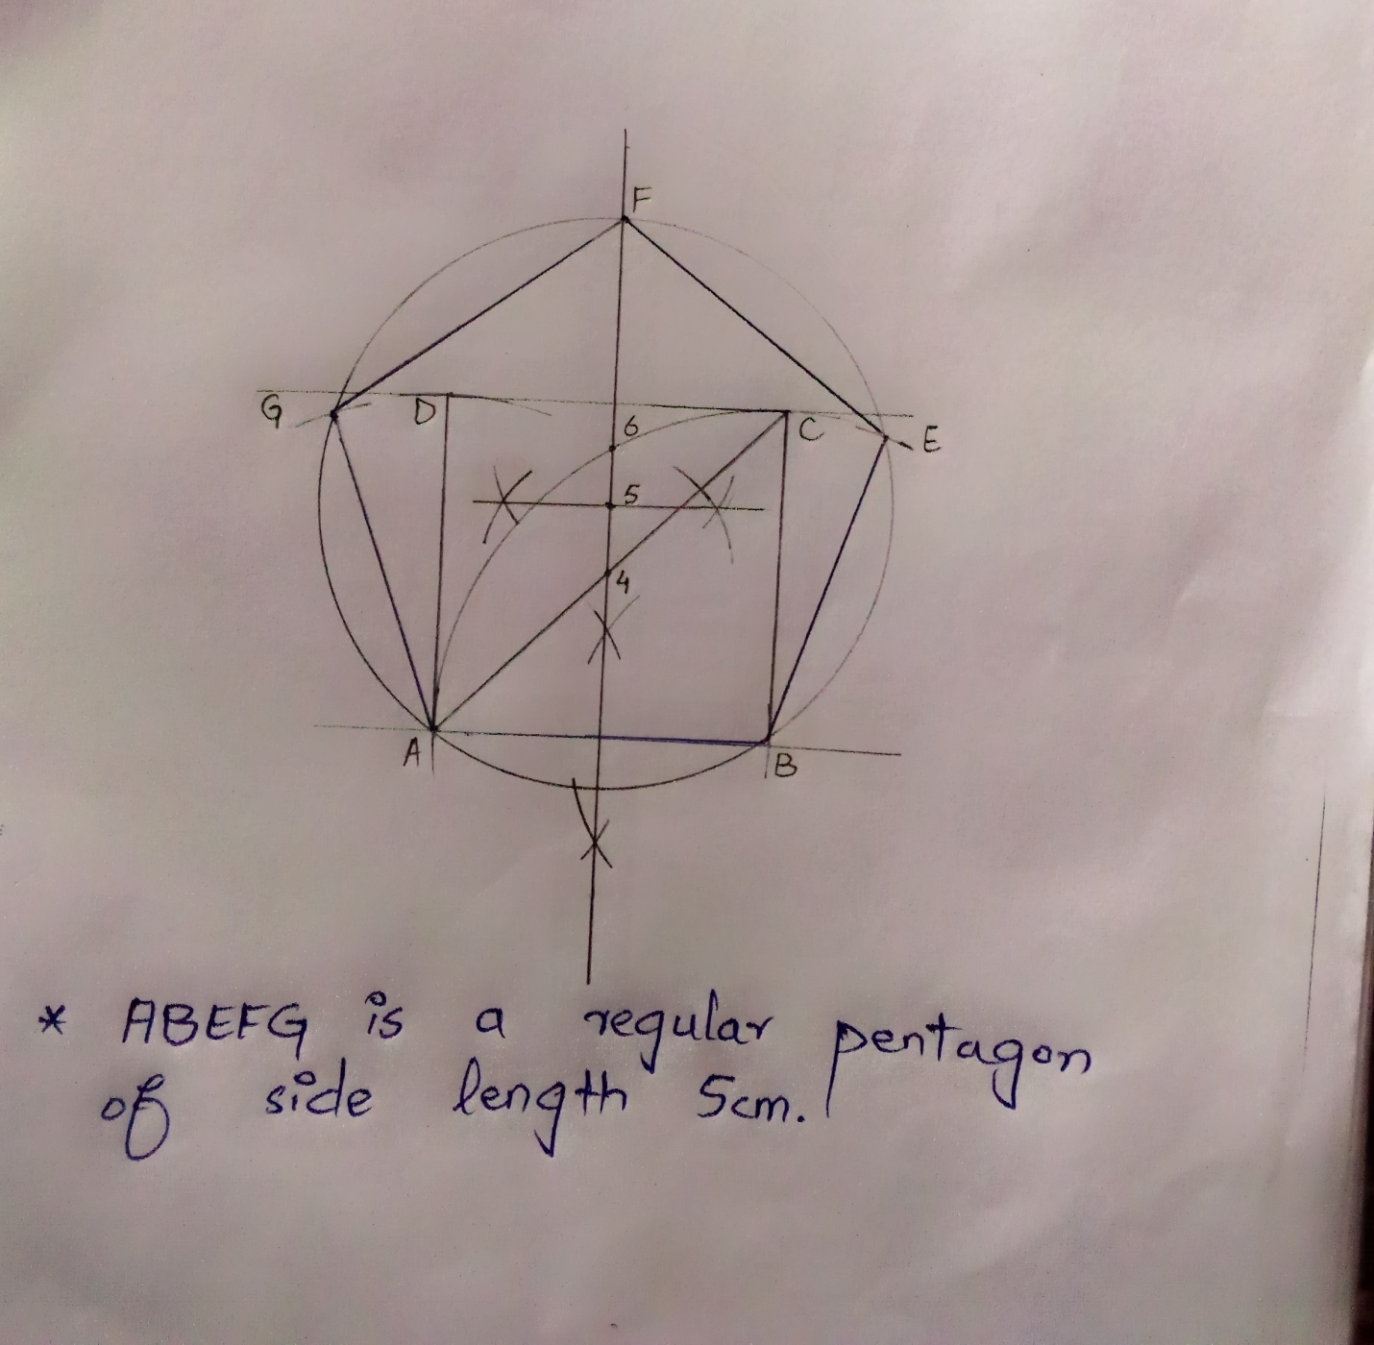

* Task no 2:
* To draw a regular hexagon having each side 5cm.

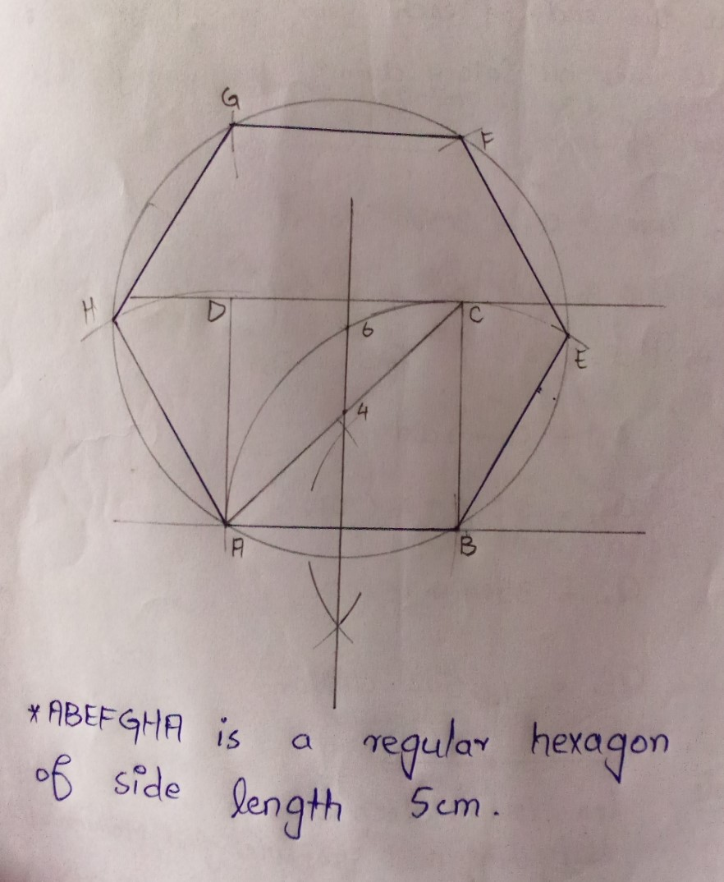

* **Task no 3:**
* To draw a regular octagon having each side 5cm.

